

Wildfire Timber Salvage Strategy Plan
Companion Guide

Version 2.0
Tenures, Compensation and Business Analysis Branch
July 24, 2026

Press ¶ for Hidden Text

Version | Date | Key Change
1.0 | 2025-11-21 | Draft
2.0 | 2026-07-24 | General edits.

Questions or comments should be directed to: ForestTenuresBranch@gov.bc.ca

Table of Contents
Goal 1
1.0 Partners and Responsibilities 2
2.0 Collaboration structure 2
3.0 Timber salvage initiatives and timing. 2
4.0 Resource and Value Considerations. 2
4.1 First Nations Values and Interests 2
4.2 Identify Other Resource Values and Management Strategy 2
4.3 Required Resource Assessments 2
4.4 Planning Retention Requirements 2
5.0 Considerations for salvage and reforestation viability 2
6.0 Establish action parameters by phase (identify areas to target, avoid, further evaluate) 2
7.0 Review burnt wood milling capacity. 3
8.0 Establish communication plan. 3
9.0 Continuous improvement initiatives 3

Goal
Prior to the active wildfire season, an action plan, by district area, will facilitate efficient timber salvage from within wildfire perimeters.
Understanding values on the land, equipment availability, who the partners are and their perspectives, and priorities in the district area may accelerate the timber salvage process in the limited window available to recover wildfire impacted timber.
Wildfire timber salvage planning must identify suitable harvest areas where adequate retention can be maintained, and successful reforestation can be achieved.
There are five phases of operational planning to consider in the Wildfire Timber Salvage Planning and Administration Guidance (Playbook). The outcome of ‘Phase 1 – Preparation: Annual Readiness’ is the development of a shared, local consensus-based ‘wildfire timber salvage strategy plan’ (Strategy) for the natural resource district area.
This Strategy Plan Companion Guide is designed to be used closely with the Playbook and is intended to be a living document that is reviewed on an annual basis. How each district Strategy is formatted is up to the team creating the document and it is the content contained in this companion guide that is the important information to capture.
Figure 1- Playbook Part 1 Visual Representation
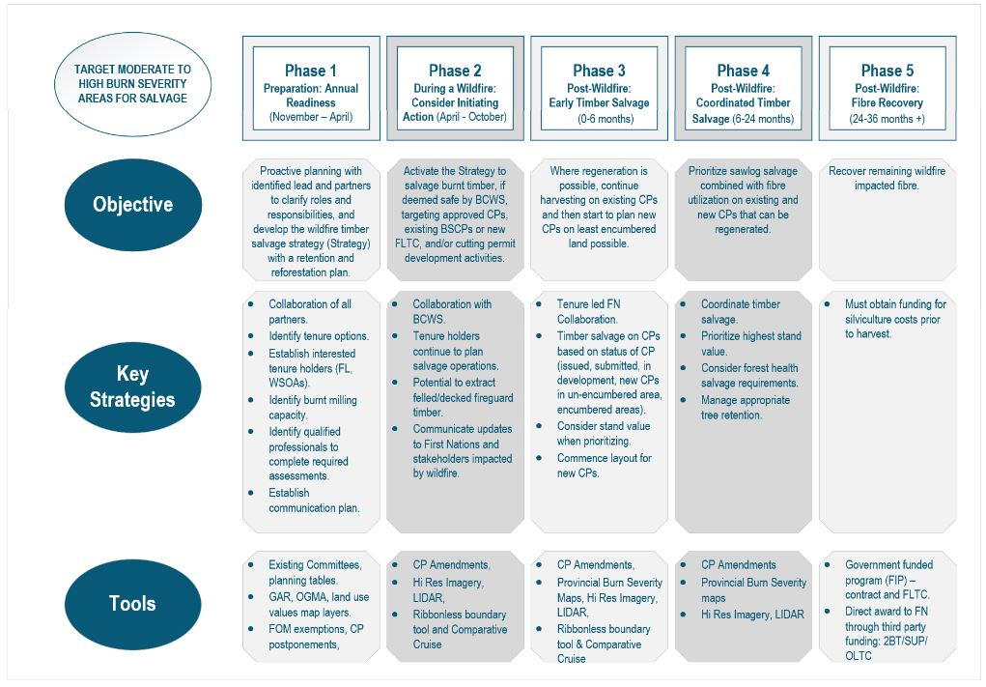

Press¶ for hidden text.

1.0 Partners and Responsibilities

1.1 Collaborating Partners.

1.2 Contributions for each phase.

Phase 1: Preparation - Annual Readiness

Phase 2: During Wildfire: prioritize recovery of high value, burnt sawlog

Phase 3: Post - Wildfire - Early: prioritize recovery of high value, burnt sawlog.

Phase 4: Post - Wildfire - Coordinated: prioritize recovery of high value, burnt sawlog and fibre utilization.

Phase 5: Post - Wildfire: prioritize fibre utilization.

2.0 Collaboration structure

3.0 Timber salvage initiatives and timing.

Phase 2: During Wildfire: prioritize recovery of high value, burnt sawlog.

Phase 3: Post – Wildfire – Early: prioritize recovery of high value, burnt sawlog.

Phase 4: Post – Wildfire – Coordinated: prioritize recovery of high value, burnt sawlog and fibre utilization.

Phase 5: Post – Wildfire: prioritize fibre utilization.

4.0 Resource and Value Considerations.

4.1 First Nations Values and Interests

4.2 Identify Other Resource Values and Management Strategy

4.3 Required Resource Assessments

4.4 Planning Retention Requirements

5.0 Considerations for salvage and reforestation viability

6.0 Establish action parameters by phase (identify areas to target, avoid, further evaluate)

Phase 2:

Phase 3:

Phase 4:

Phase 5:

7.0 Review burnt wood milling capacity.

8.0 Establish communication plan.

Phase 2:

Phase 3:

Phase 4:

Phase 5:

9.0 Continuous improvement initiatives

